Memory [C]

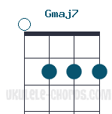
[C] Midnight, not a sound from the [Am] pavement Has the moon lost her
[F] memory? She is smiling a[Em]lone In the [Dm] lamplight, the withered leaves co[Am]llect at my feet And the [G] wind be[F]gins to [C] moan
[C] Memory, all alone in the [Am] moonlight I can smile at the
[F] old days I was beautiful [Em] then I re[Dm]member the time I knew what
[Am] happiness was Let the [G] memory [F] live a[C]gain
[Em] Every [F] streetlamp [Em] seems to [F] beat a [Em] fata[C]lis[D]tic [G] warning [Em] Someone [Am] mutters, and a [D] streetlamp [Gmaj7] gutters, And [Em] soon it [A7] will be [D] morning.
[C] Daylight, I must wait for the [Am] sunrise I must think of a [F] new life And I mustn't give [Em] in. When the [Dm] dawn comes, tonight will be a [Am] memory too And a [G] new day [F] will be[C]gin

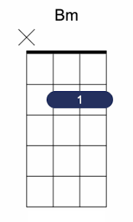
[G] Midnight, not a sound from the [Em] pavement Has the moon lost her
[C] memory? She is smiling a[Bm]lone In the [Am] lamplight, the withered leaves co[Em]llect at my feet And the [D] wind be[C]gins to [G] moan

